…Module-info.java file…

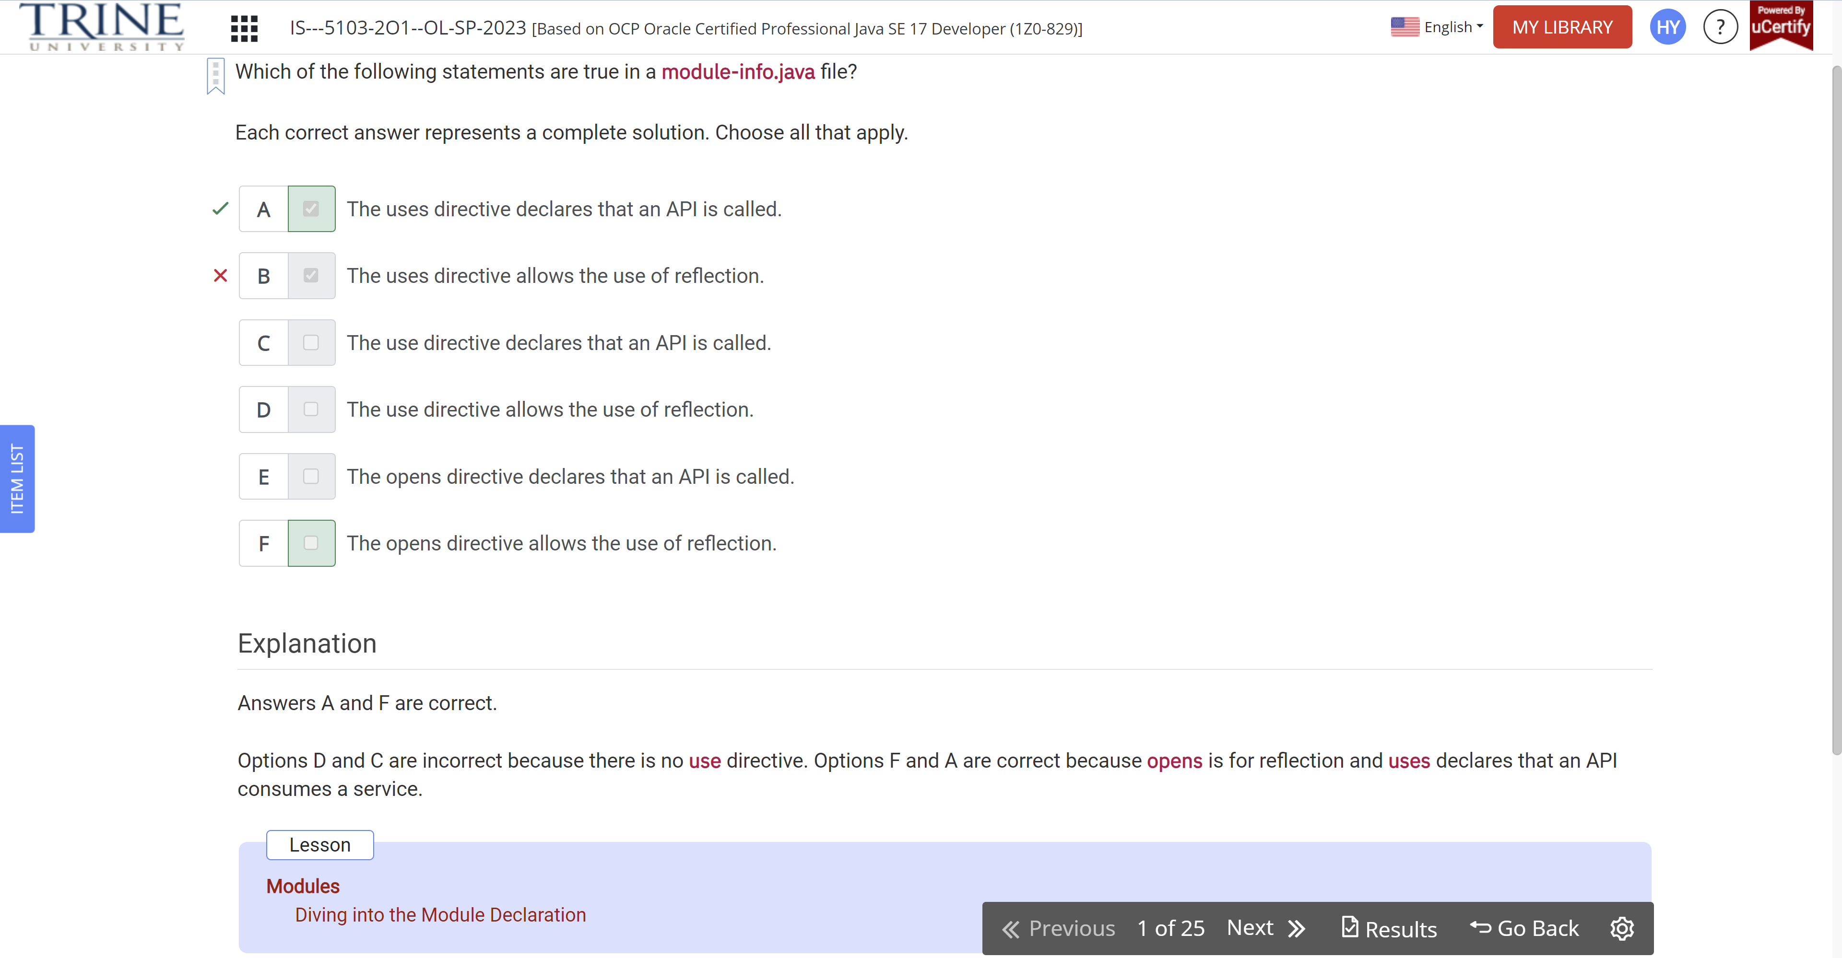

Puppy… dog…

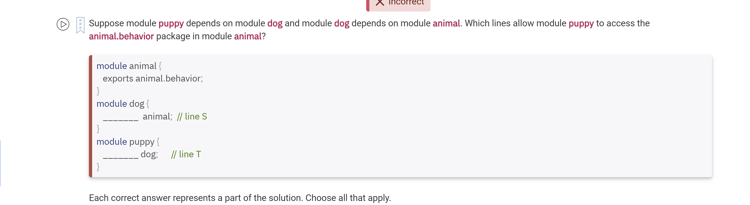

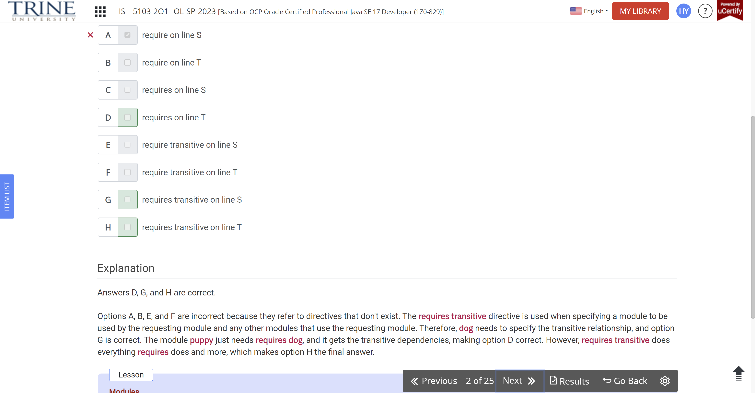

…Cat-1.2.3-RC1.jar…

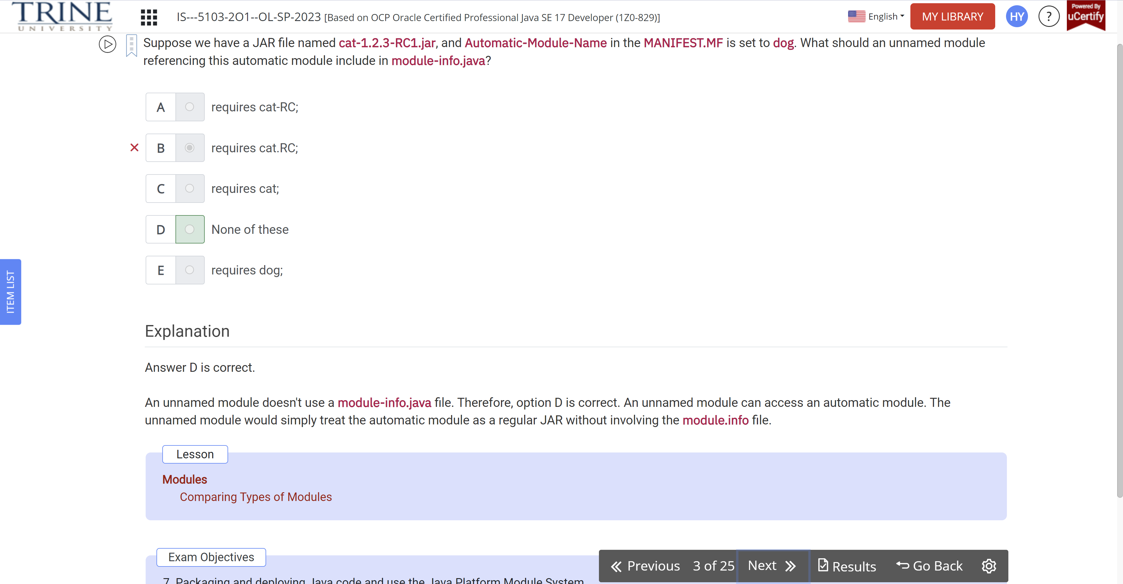

Class dragon…

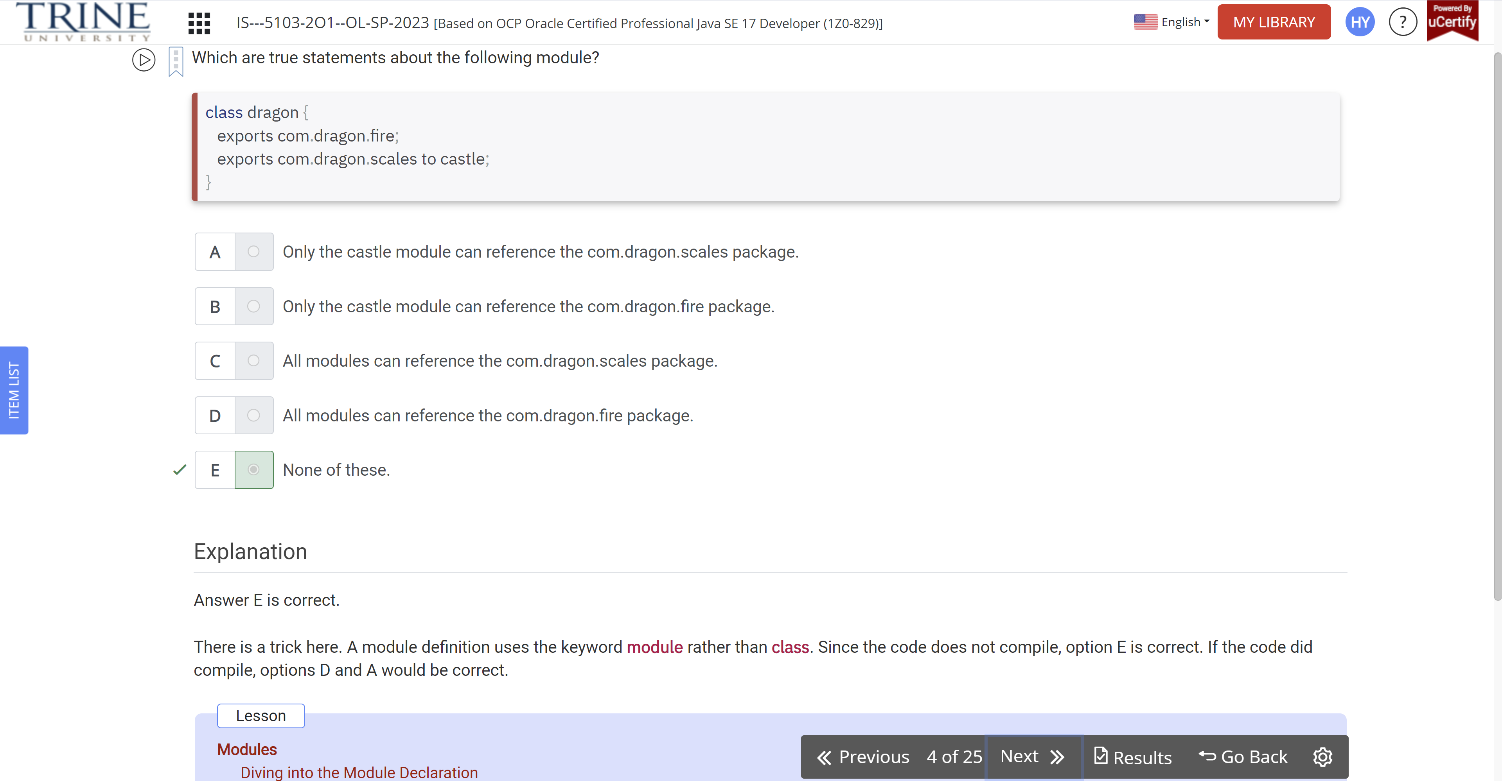

Java ---zoo.animal.talks..

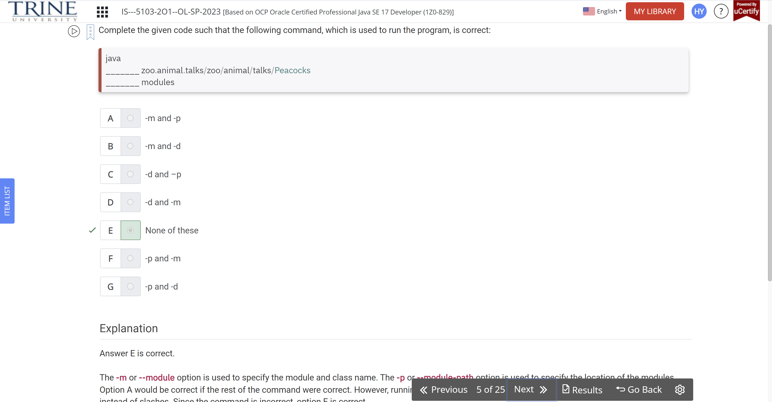

…make up a service.

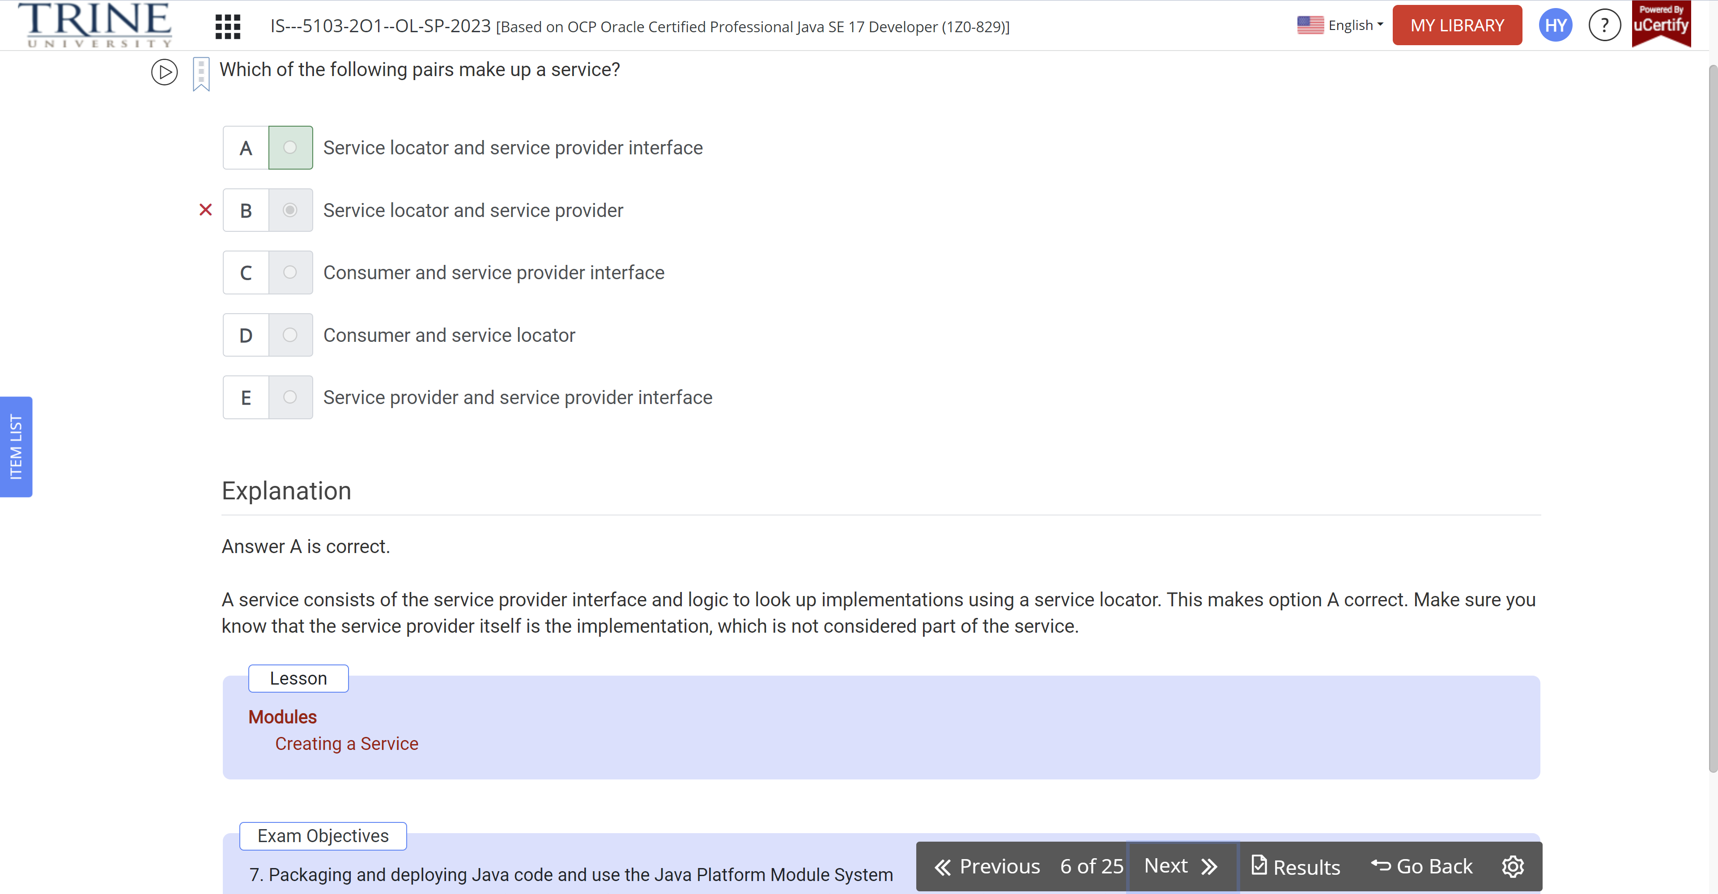

Suppose you have separate modules …service provider interface, …

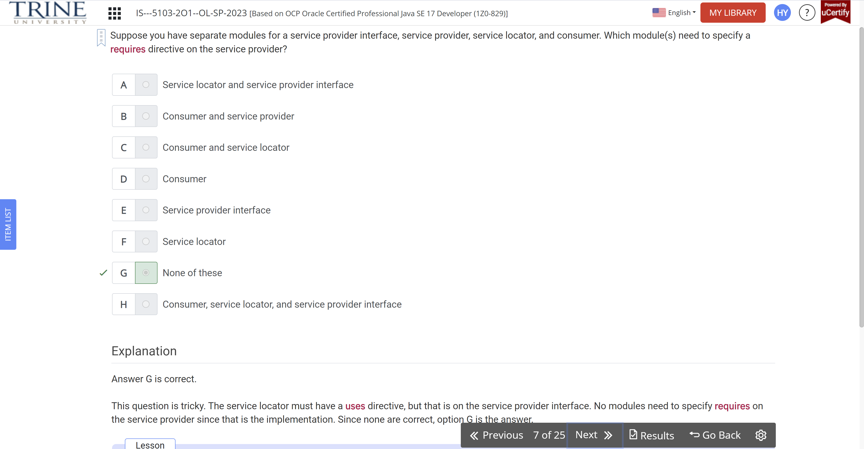

An automatic module name … JAR filenames …

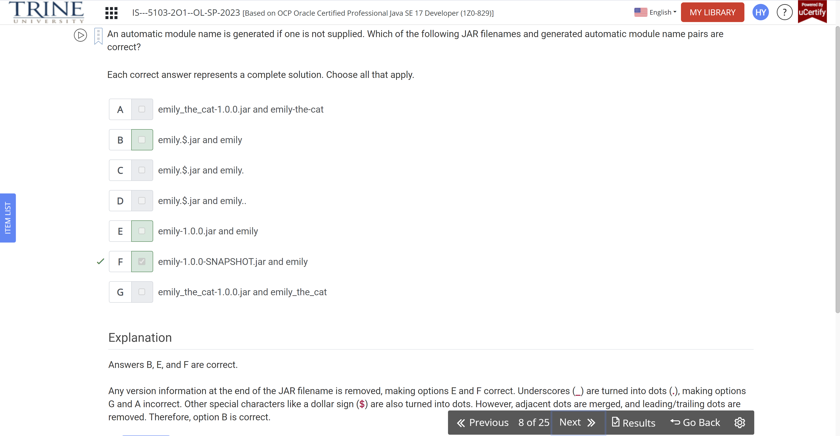

Which are true statements … in a JAR on the classpath…

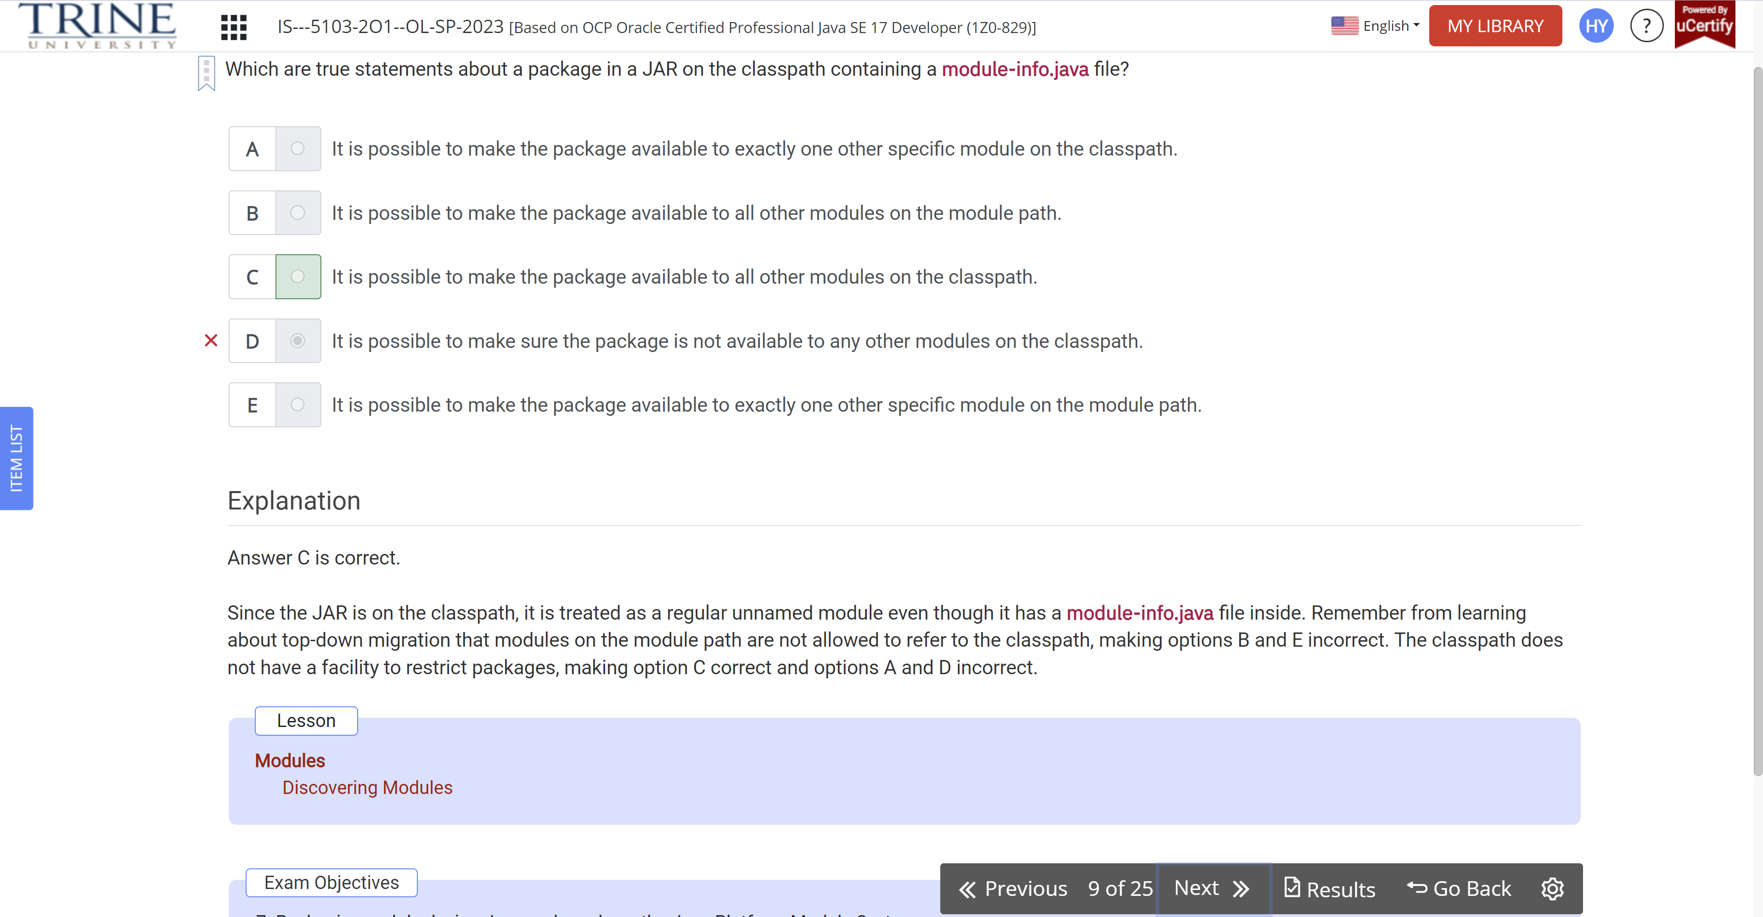

Which commands are used to a smaller Java image and work with native code, respectively

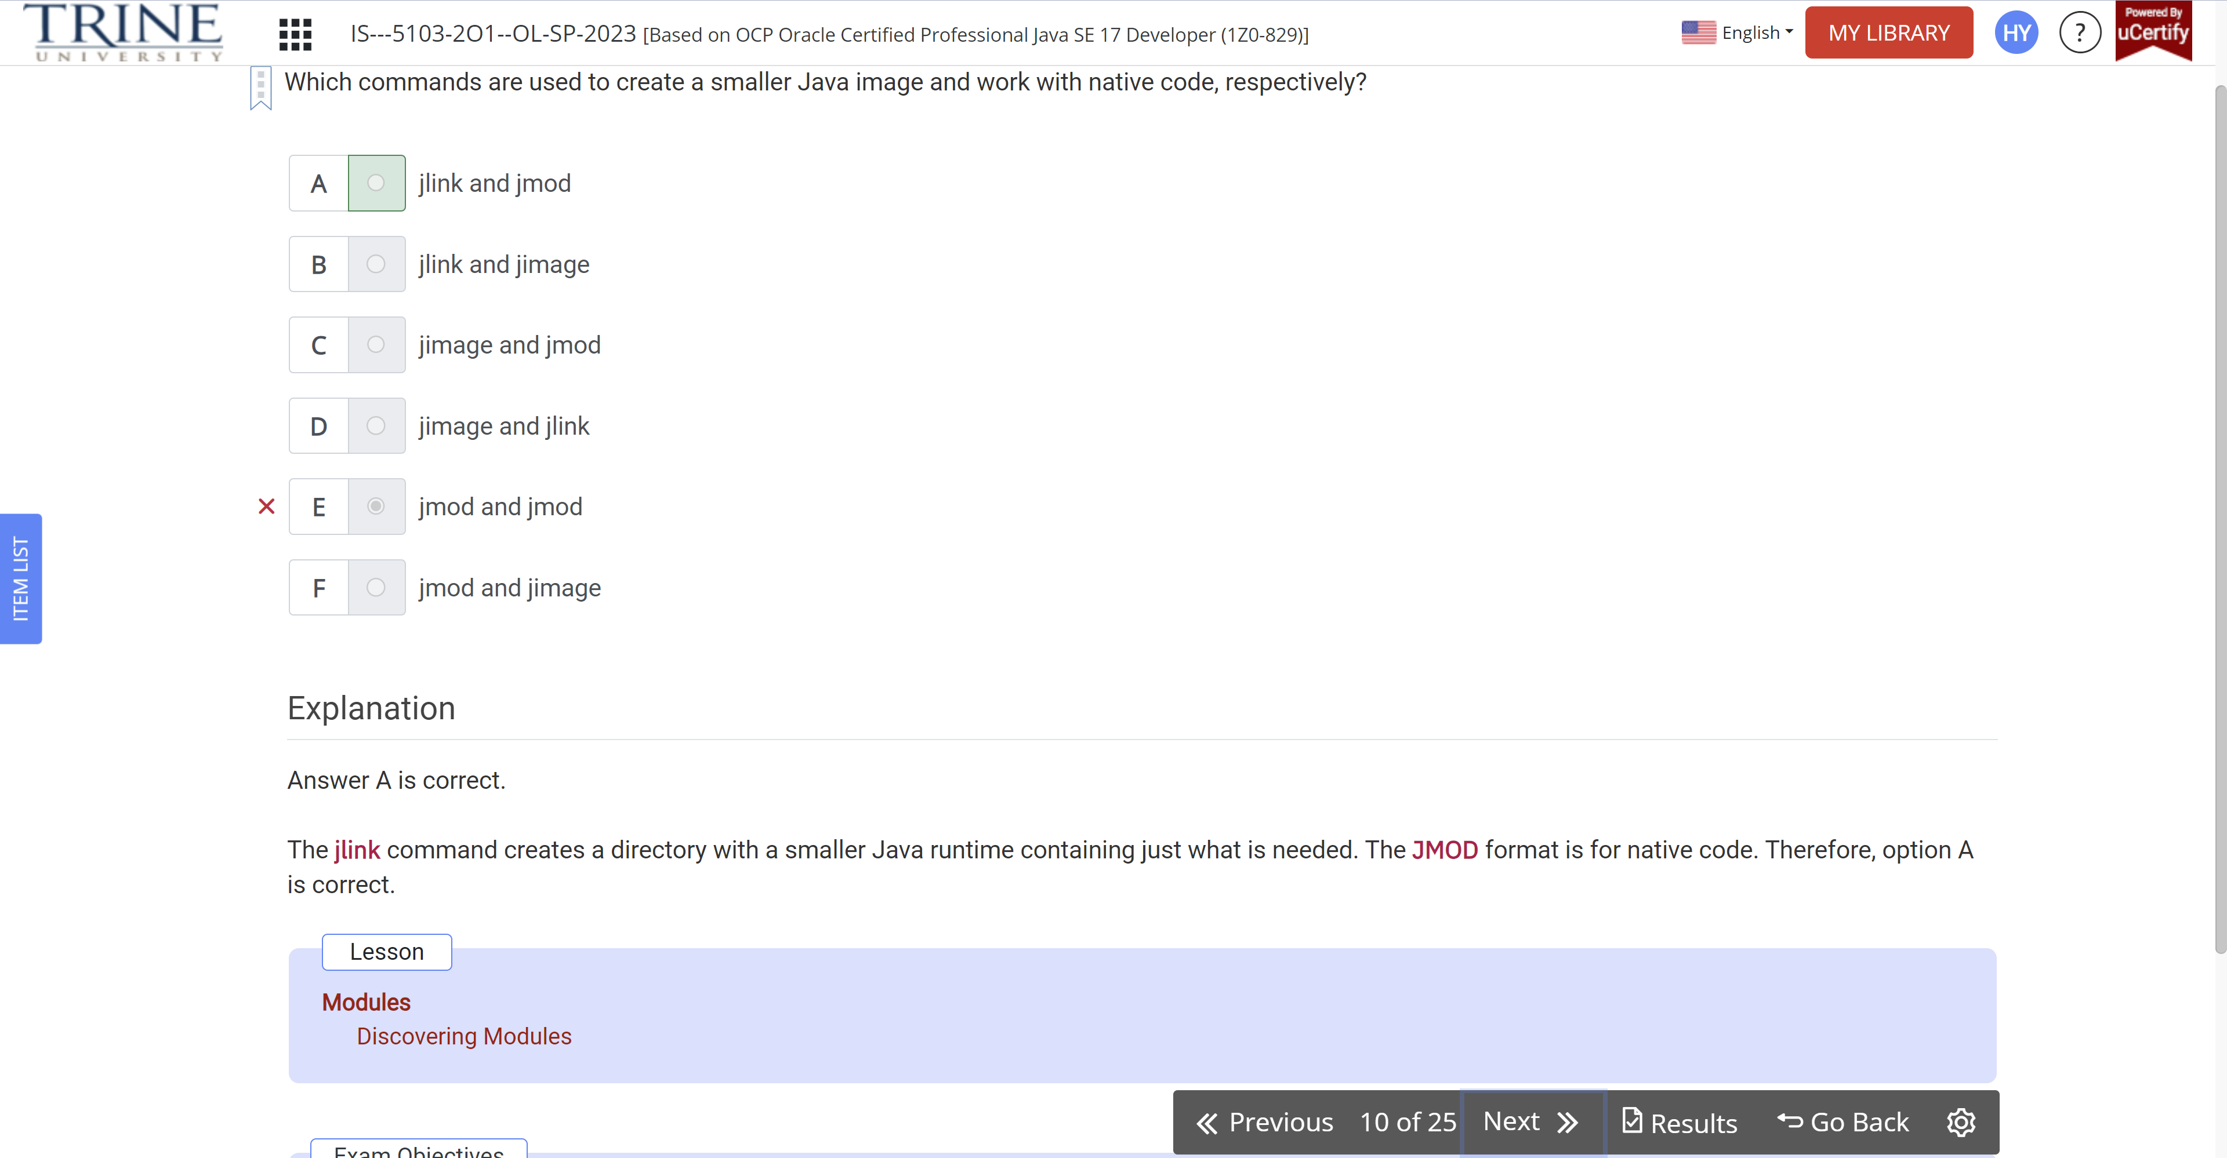

Suppose module puppy depends on … in module animal

Module animal …

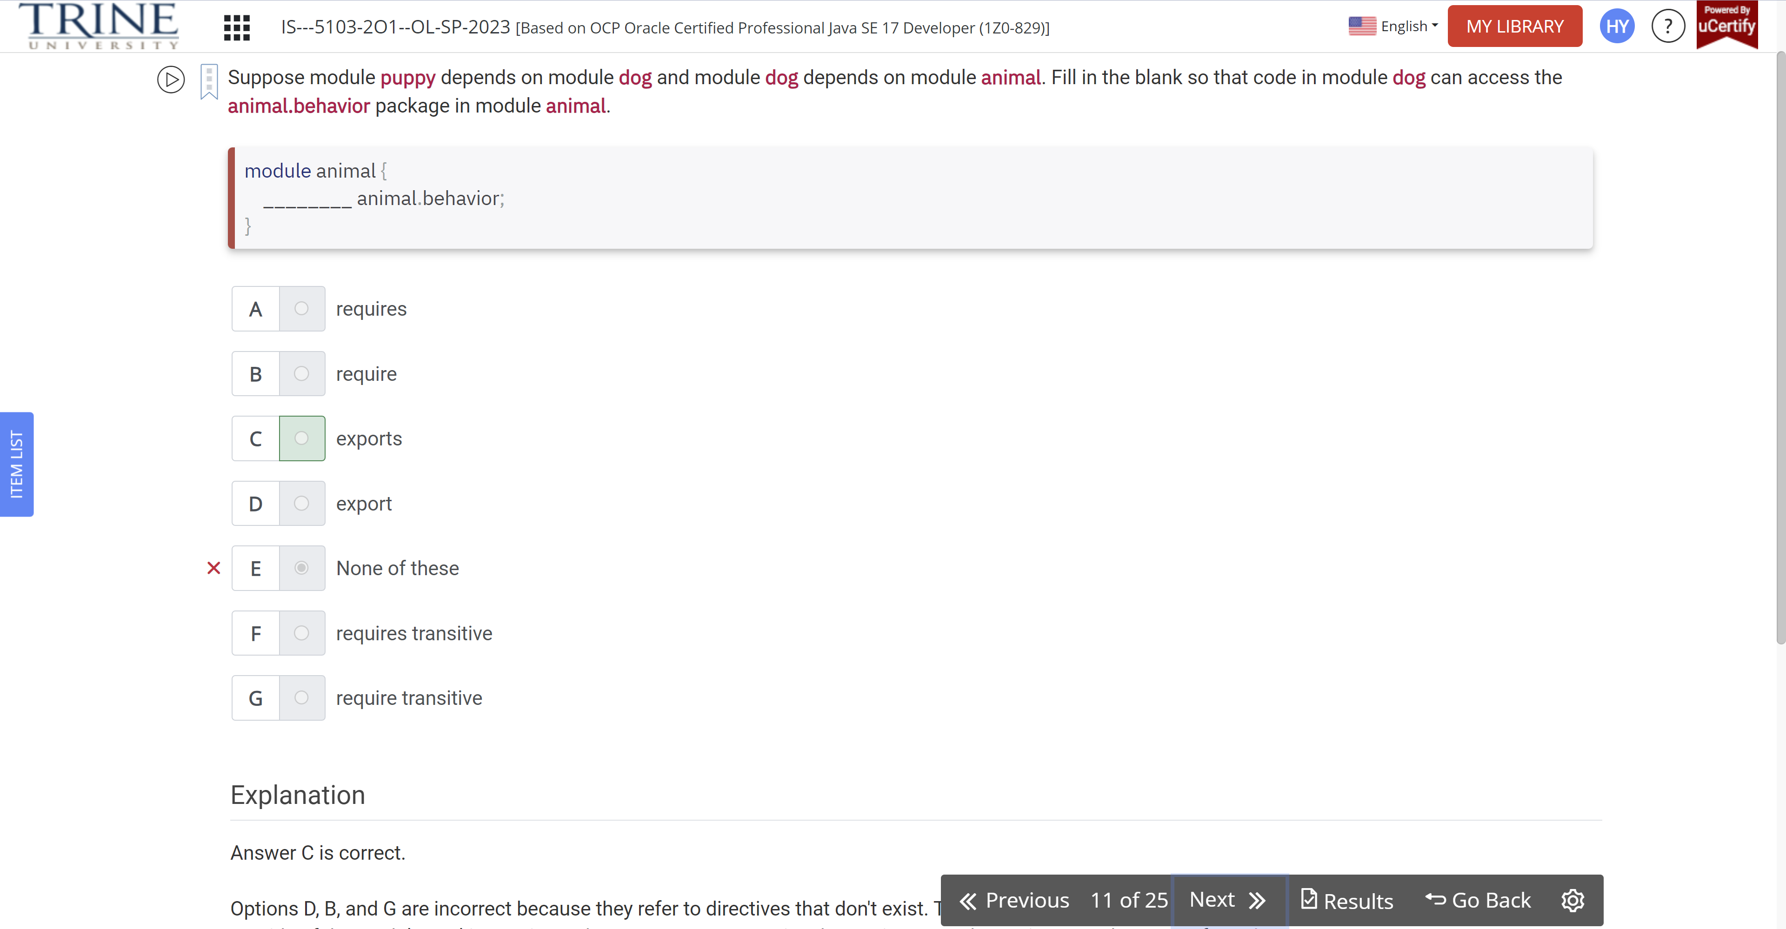

Suppose you have separate modules … for a service provider interface, service provider, ….

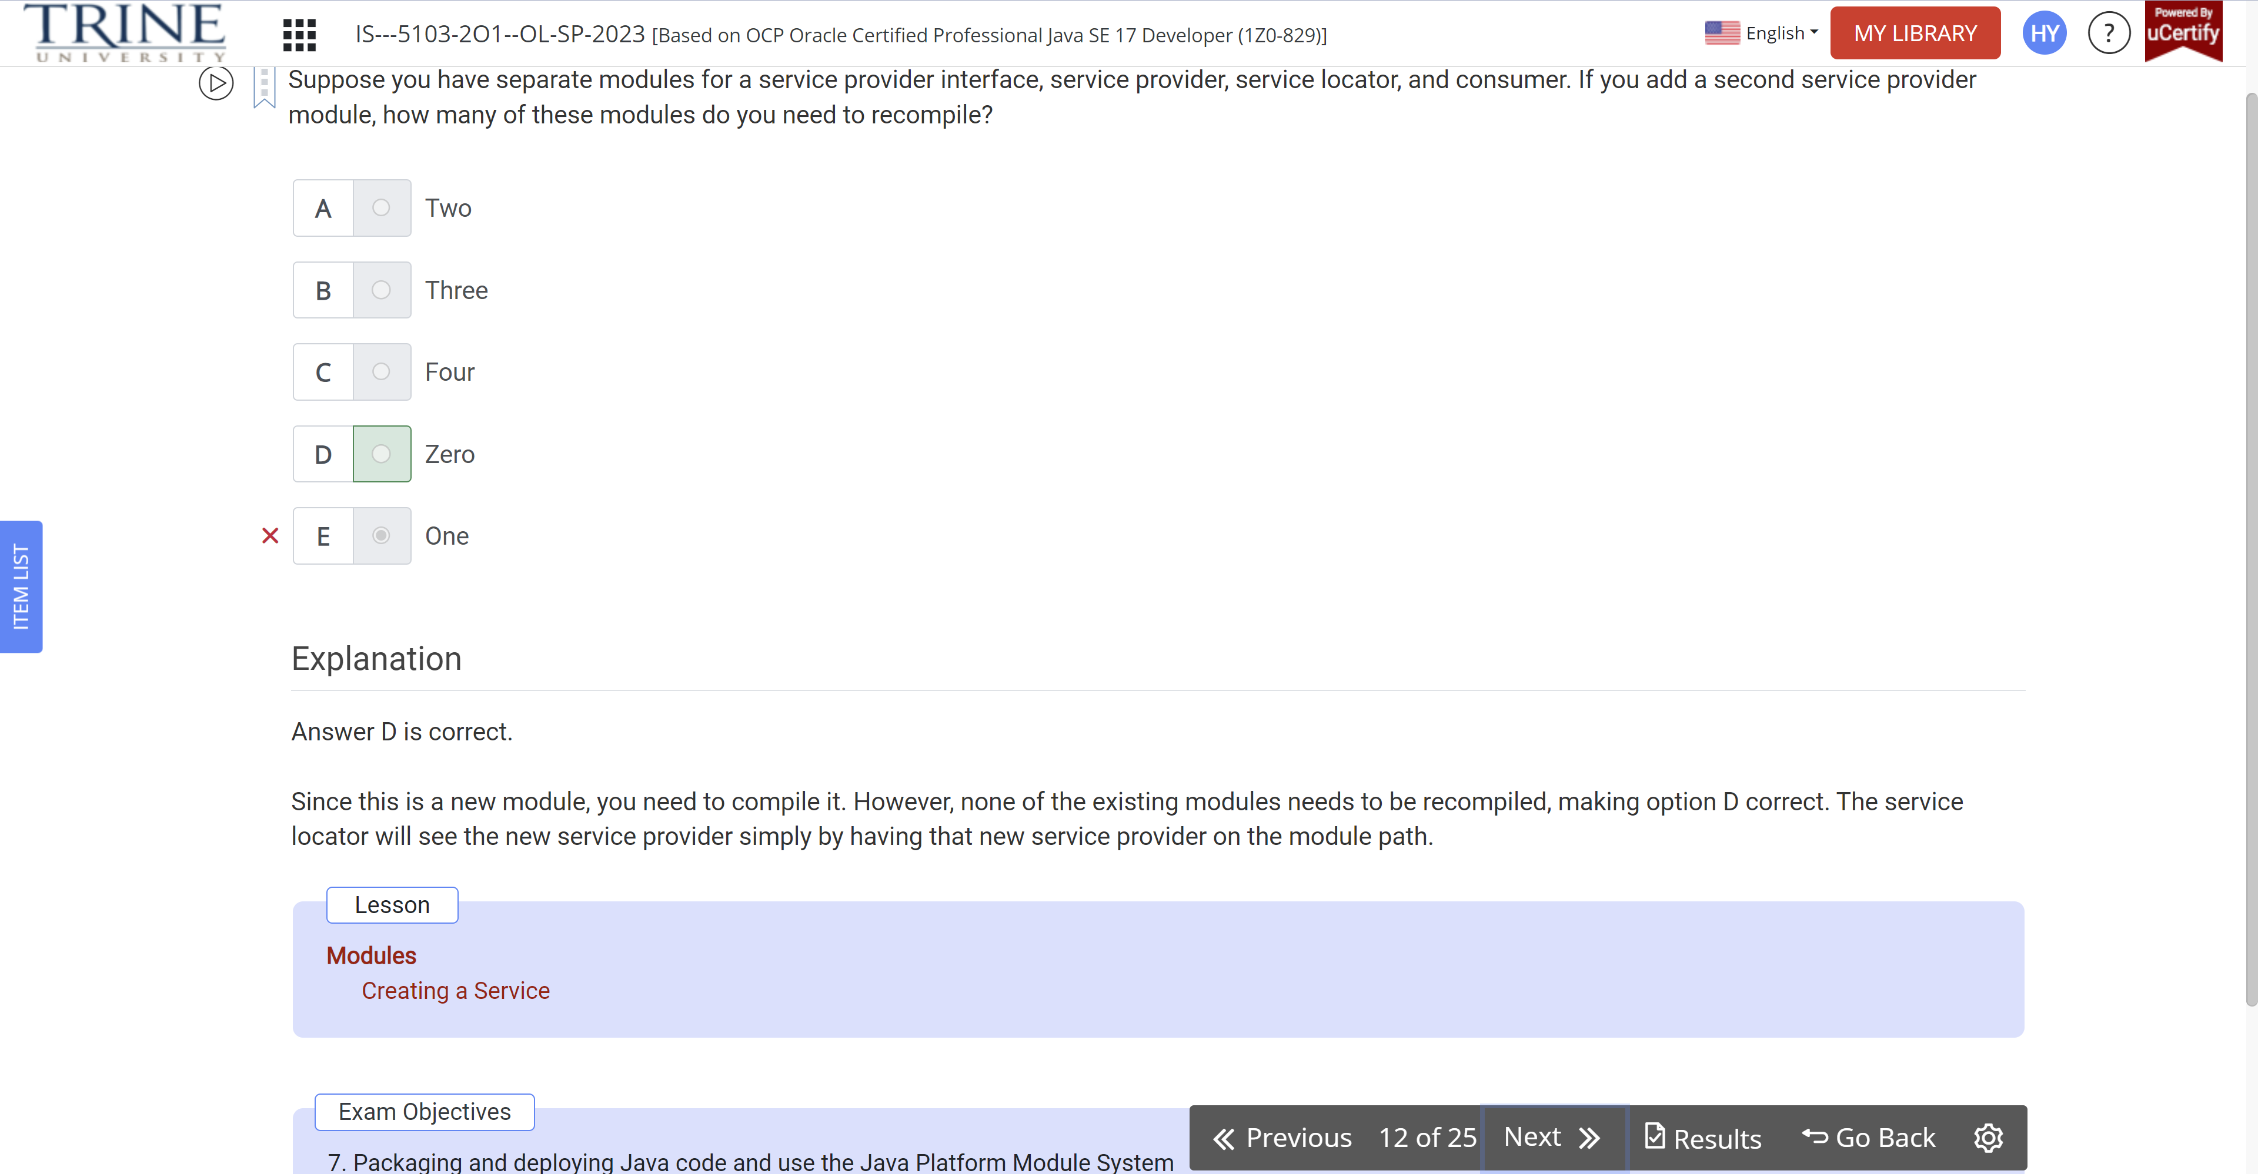

List<Unicorn> all = …

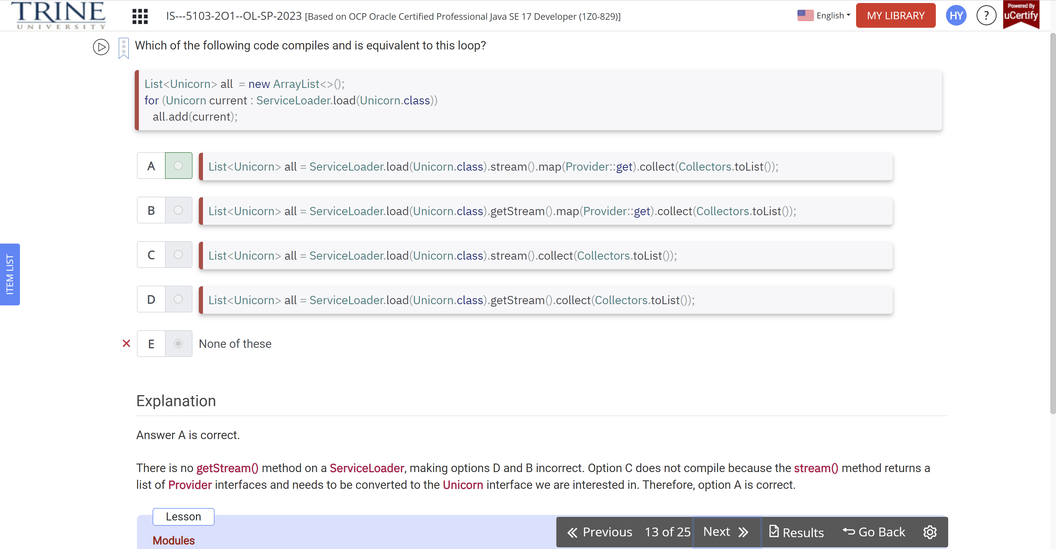

Module-info.java

Package dragon;

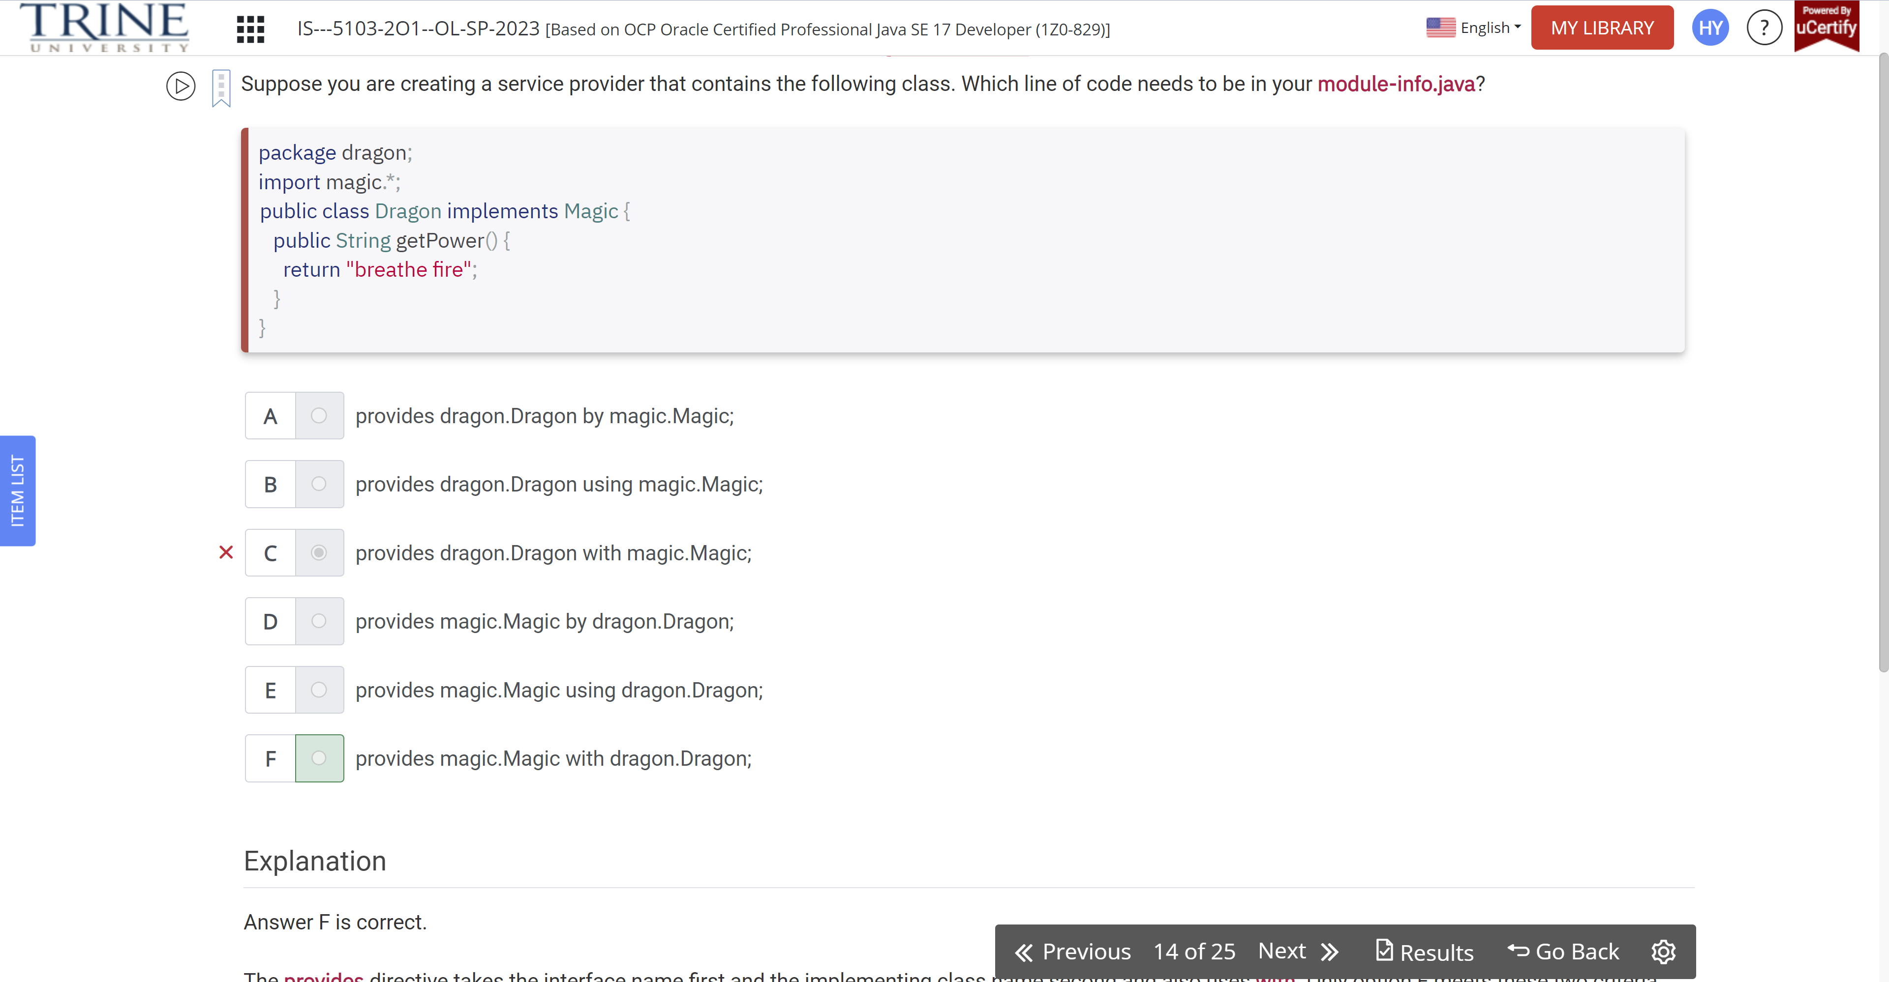

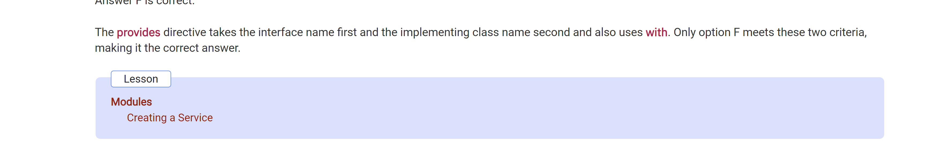

Which of the following modules are provided by the JDK

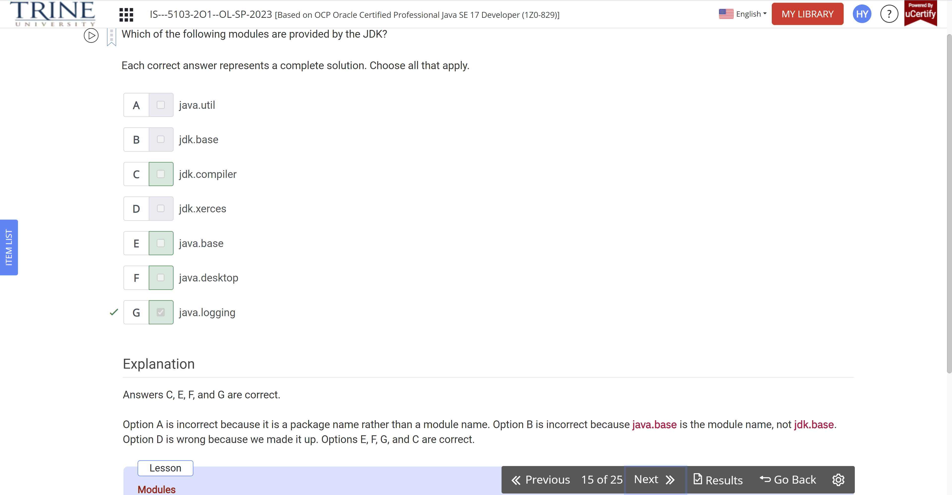

A(n)…module is on the classpath while a(n)…

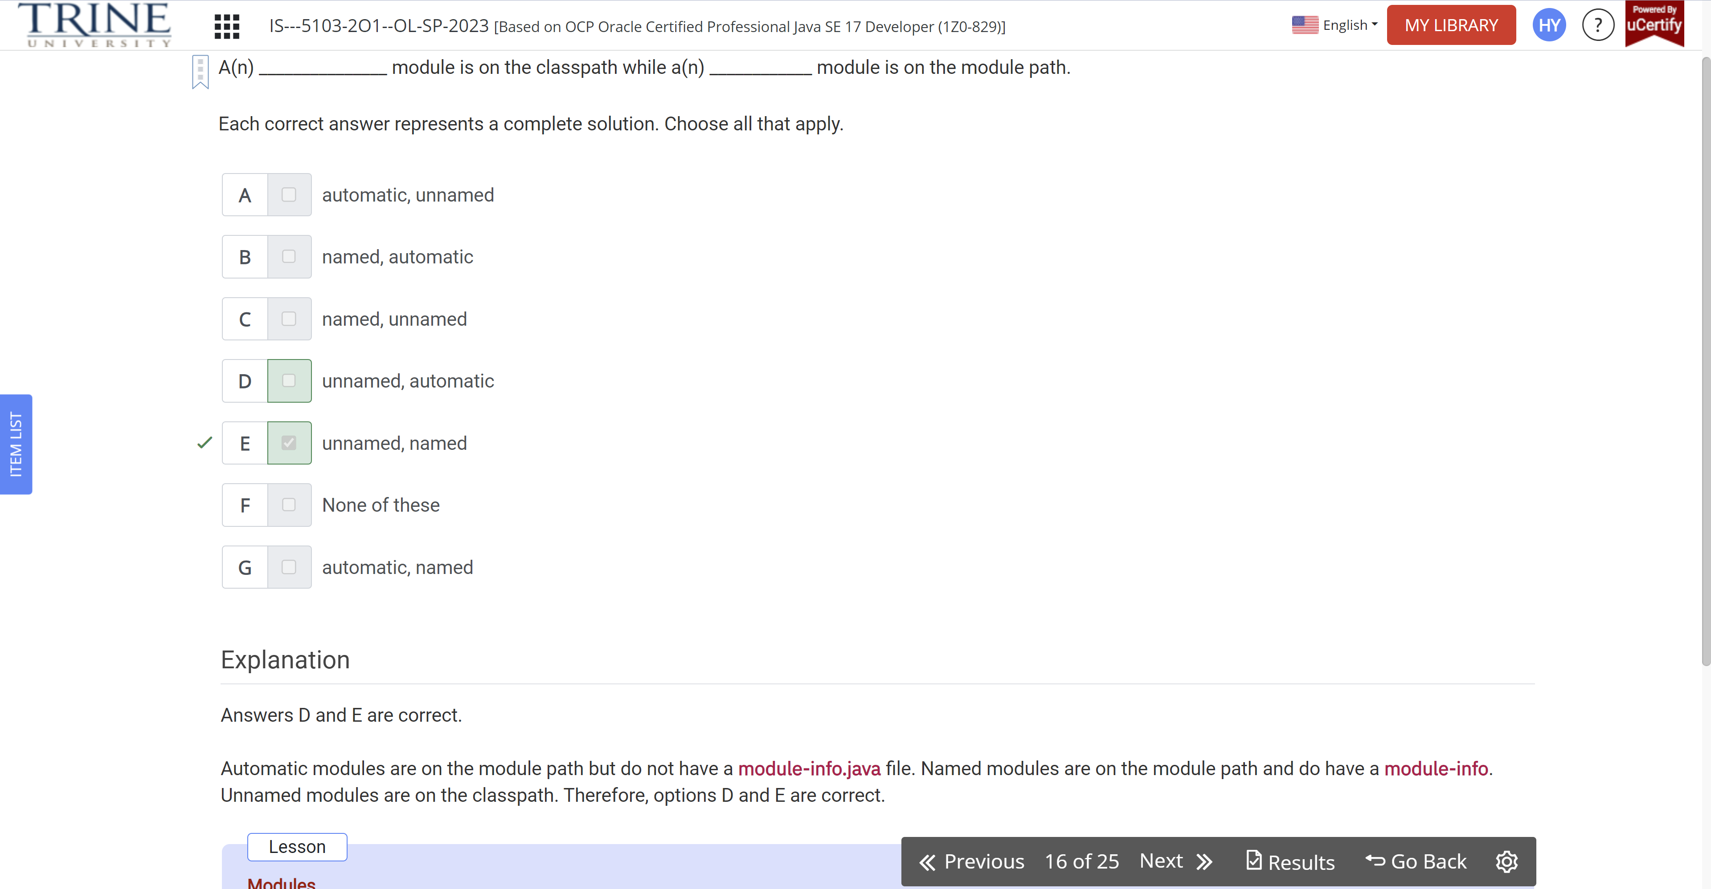

Which of the following …

Module com.food.supplier ..

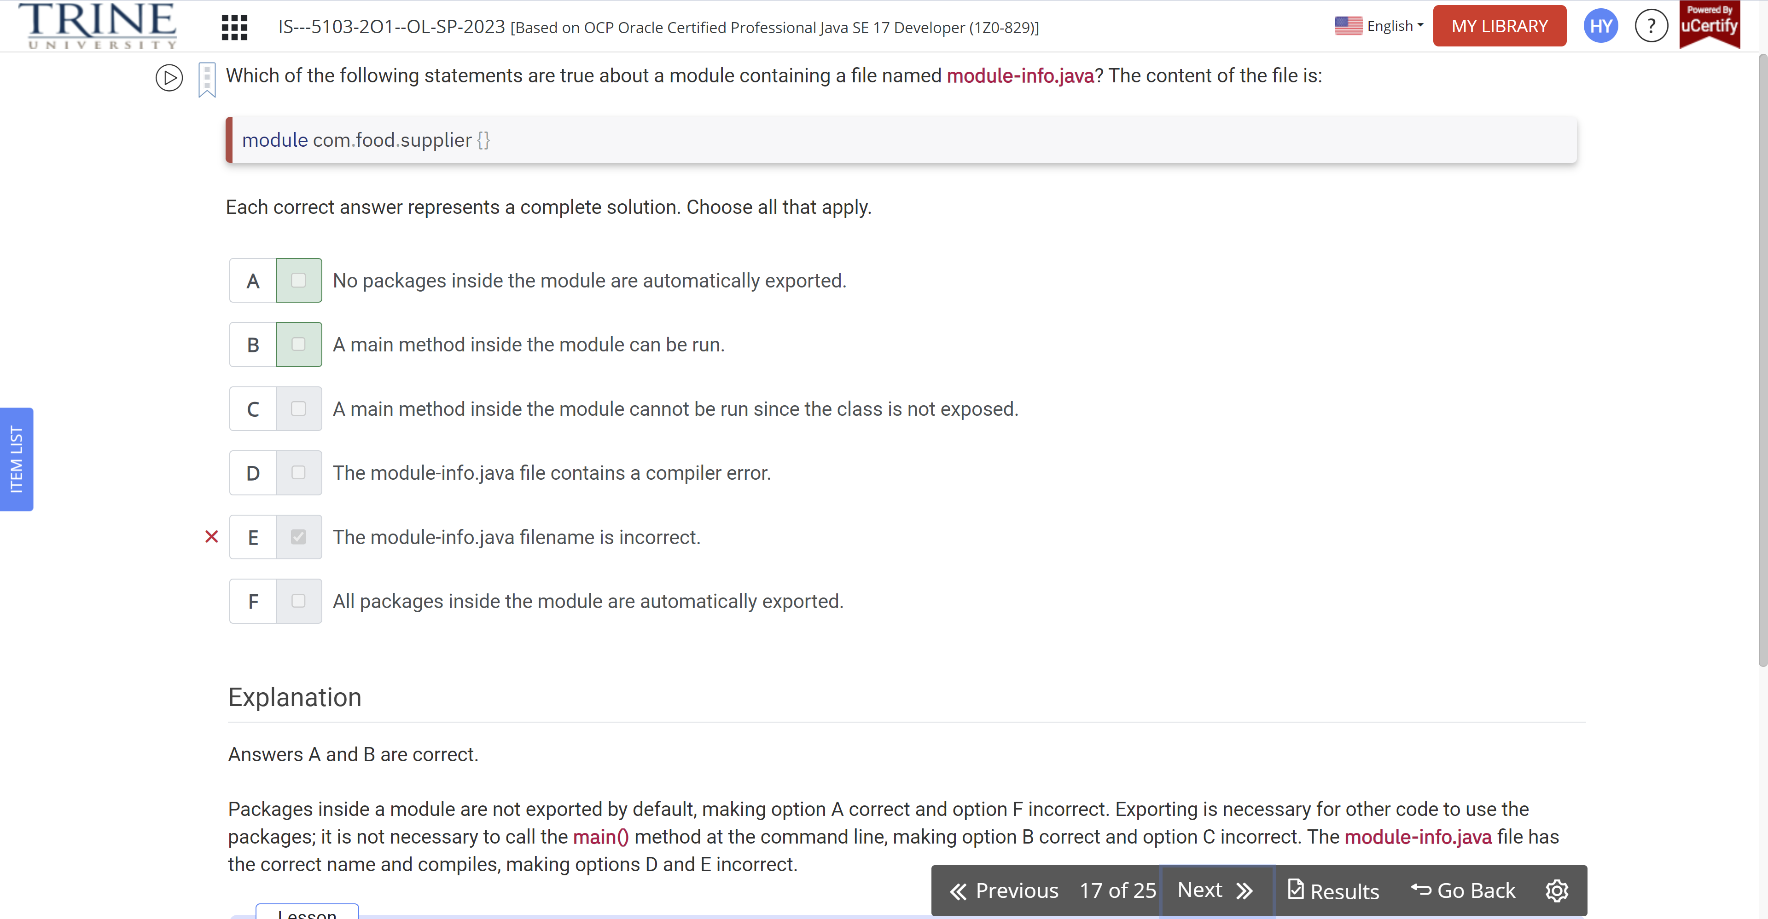

Suppose you have separate modules for a … Which statements are true about the directives you need to specify?

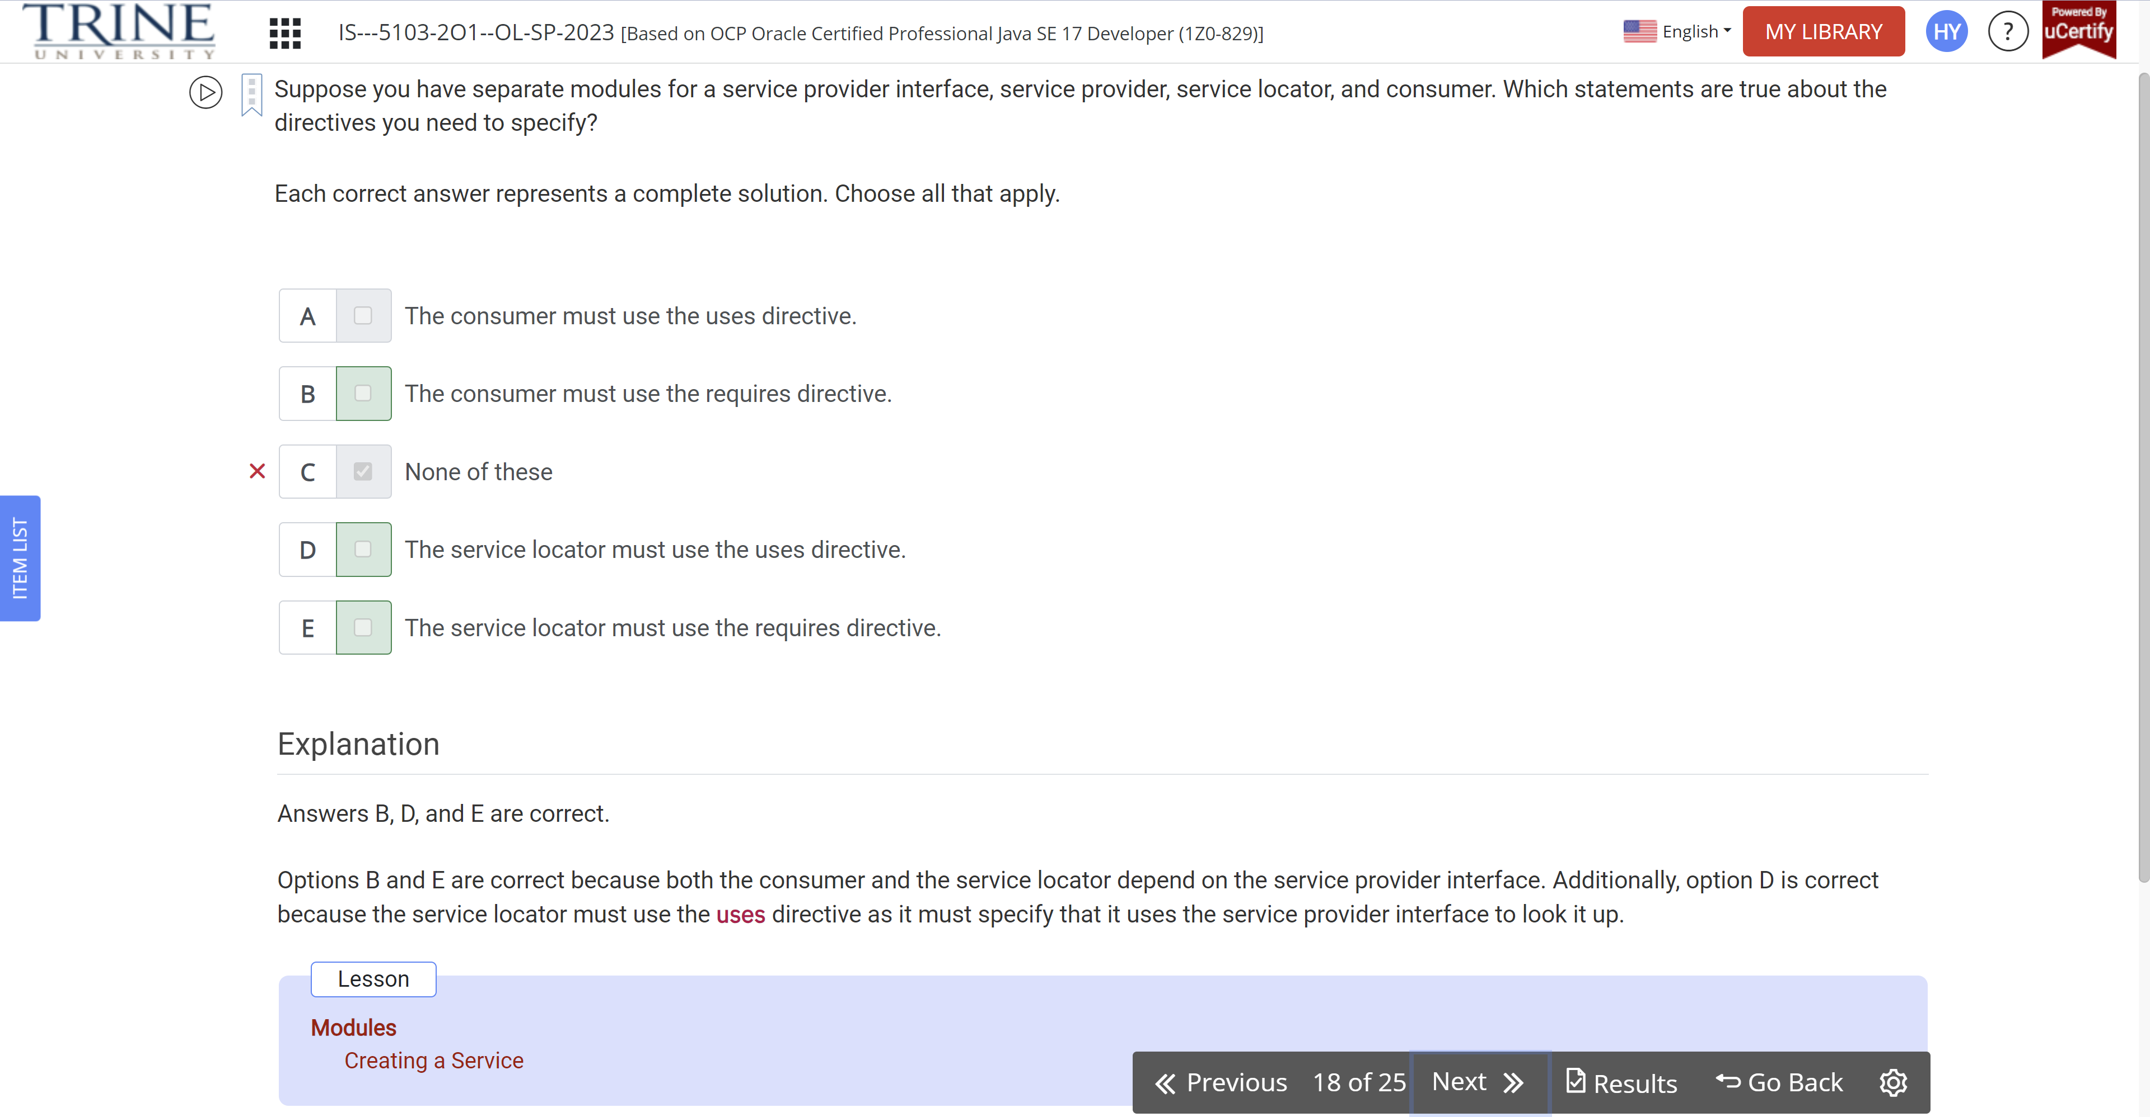

Which of the following statements are true?

Cyclic..

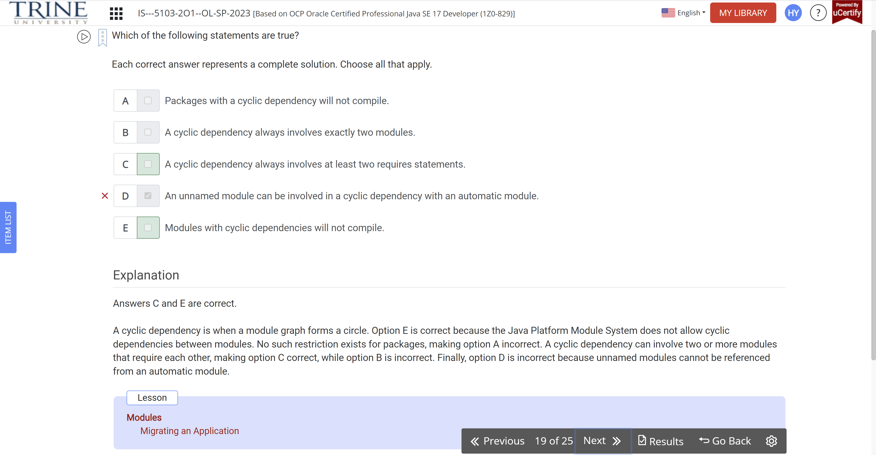

Which is the first line to contain a compiler error?

module snake…

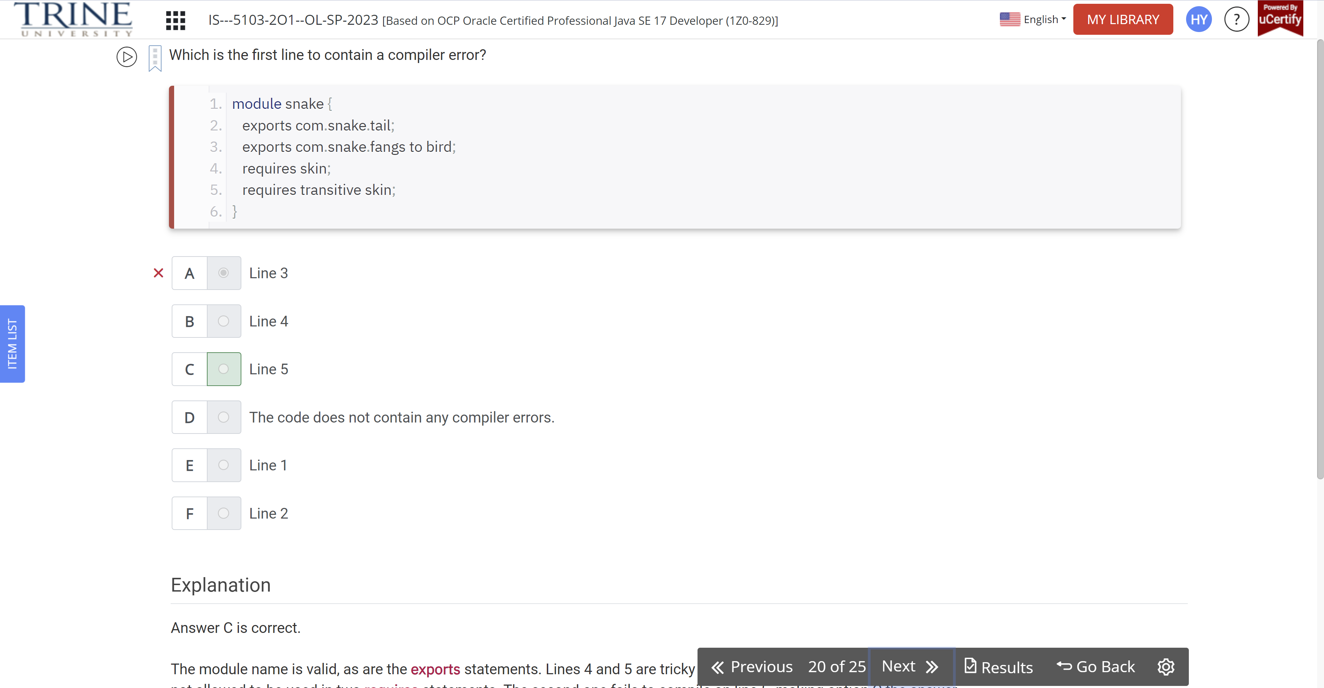

Which are true statements?

An automatic module …

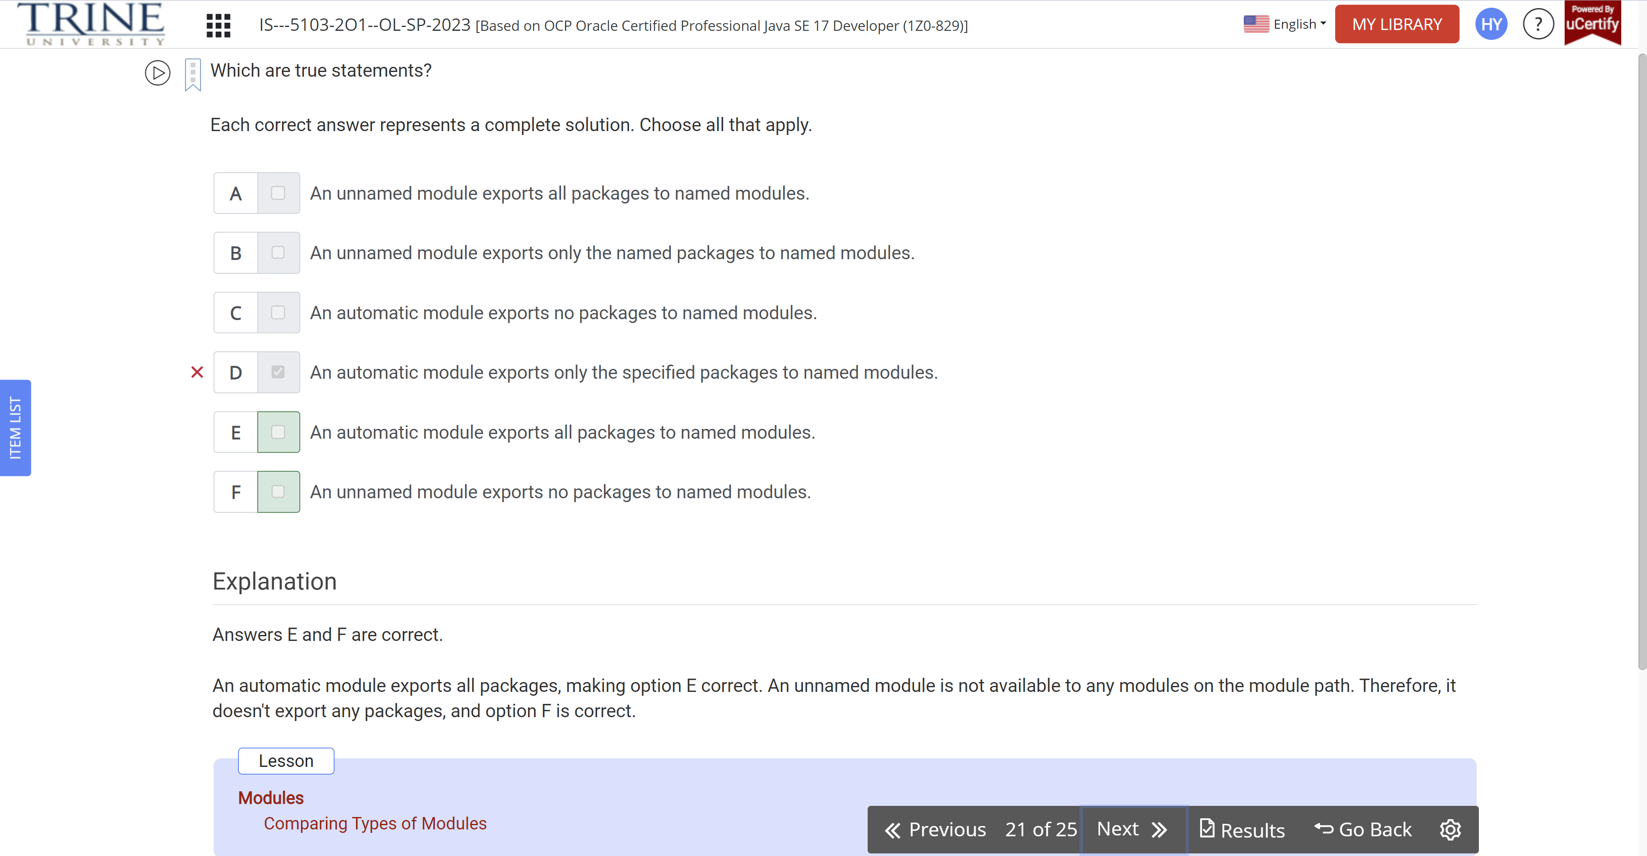

Which of the following are legal commands to run a modular program. ..

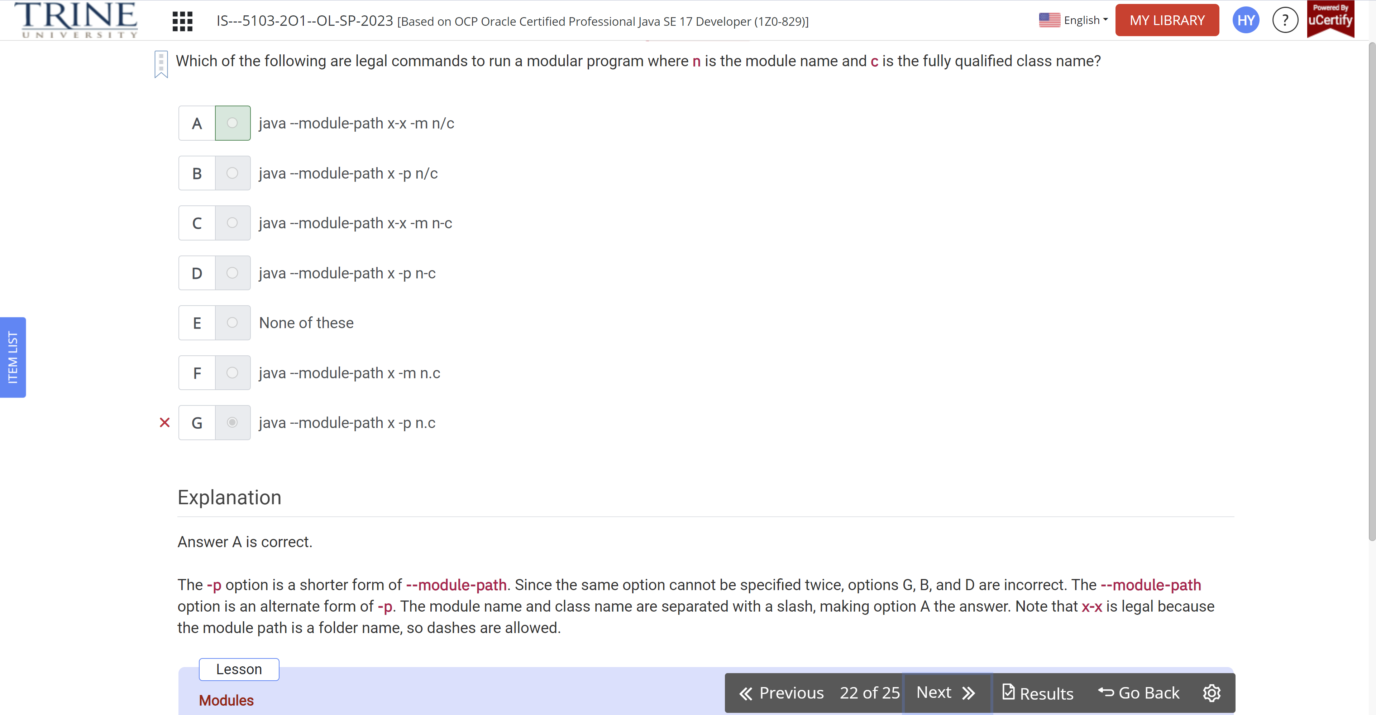

Which would you expect to see when describing any module?

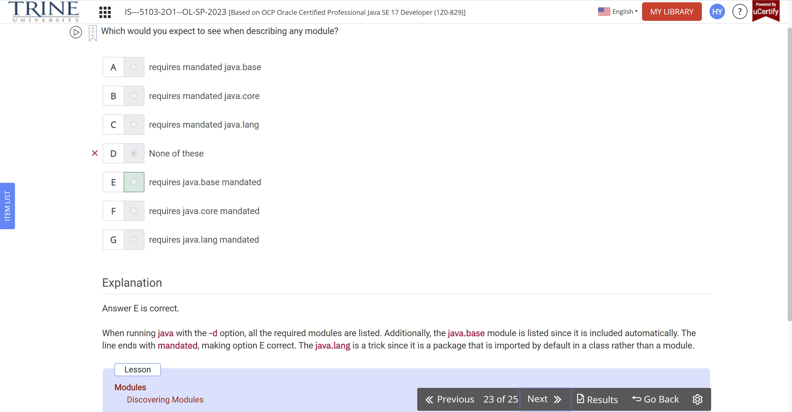

Which statements is true of the following module?

---zoo

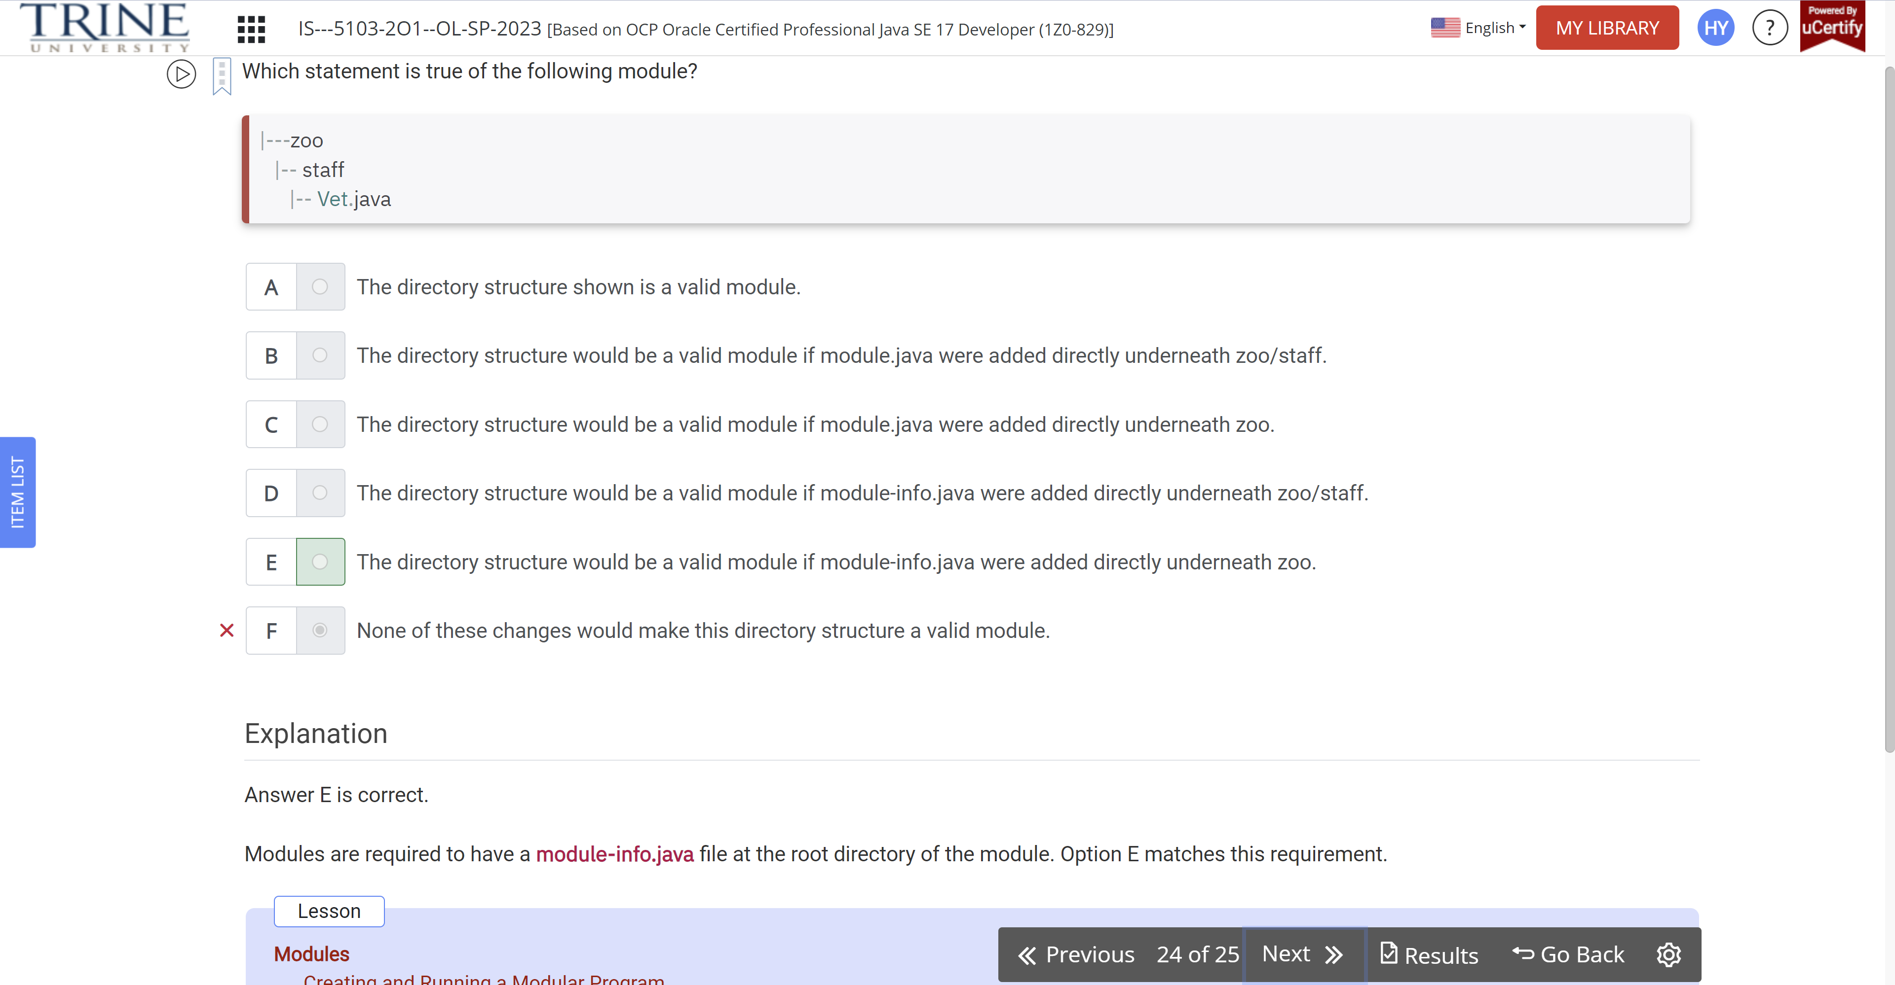

For a top-down migration…

